Personalized data API

Thanks for taking the time to work on this assignment.

One of our modules in NielsenIQ is an API service that provides shoppers with personalized information to eCommerce servers.

The service consists of 2 main parts:

1. Interface with data team (internal) – Receiving shoppers’ personalized information and product metadata from our data team and storing it in a specified database.
2. Interface with eCommerce (external) - Provide fast read operation for the shoppers’ personalized information.

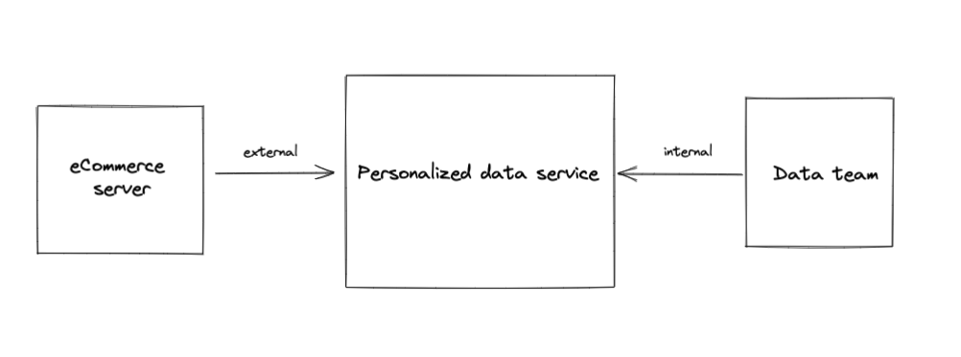

**Interface with data team:**

* Shopper personalized product list

{

"shopperId": "S-1000",

"shelf": [

{

"productId": "MB-2093193398",

"relevancyScore": 31.089209569320897

},

{  
 "productId": "BB-2144746855", "relevancyScore": 55.16626010671777

},

{

"productId": "MD-543564697",

"relevancyScore": 73.01492966268303

}

] }

* Product Metadata

{

"productId": "BB-2144746855",

"category": "Babies",

"brand": "Babyom"

}

Interface with eCommerce:

* Get Products by shopper (with filters)
  + Shopper ID - String, required
  + Category - String, optional
  + Brand - String, optional
  + Limit - Integer, optional, default = 10, max = 100
* Get shopper by product
  + Product ID - String, required
  + Limit - Integer, optional, default = 10, max = 1000

Your task is to implement a service that answers the interfaces above (both internal & eCommerce interfaces).

**Task review**

On your task review you should be able to:

* Run live tests on the system.
* Connect to the database.
* Explain the performance considerations.

**Technical tools**

Please use the technical tools you are comfortable with

* Server - preferred: Java
* Docker – advantage

**General**

* The eCommerce interface is a real-time interface and requires high performance.
* You can use any tool or online resource you want.
* The database design and deployment are the parts of the task. Please use a persistent database
* The implementation should be as clean, readable, and efficient as possible.

Please reach out to us for consultation - as you would if you were building this service as an engineer here at NielsenIQ.

Good luck!